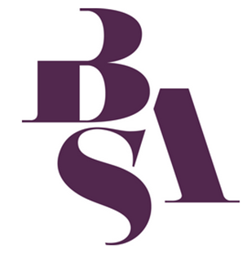
British Sociological Association
Sociology of Religion Study Group
Peter B. Clarke Memorial Prize
Essay Competition 20223

Name

Address

Phone number

Email Address

University/Institution

Programme of Study currently enrolled on (if postgraduate)

Title of Essay

Word Count

Study Group Member (you must become a member of the study group to enter the competition) | Existing member? ____  or  Recently joined? ____  (please tick)

Essays should have their pages numbered and be submitted as a single MS Word document (including this cover sheet) as an attachment to Dr Isabella Kasselstrand (isabella.kasselstrand@abdn.ac.uk)

The closing date for submission is 28 April 2023.

